The code folder contains every codes and most of the files that used in my project, due to the limitation of 40MB, I just put part of the data in the folder, this file is a introduction of how the model is built.

Dictionary.py is a dictionary filter which is extracted from the ‘Taxonomy of Neuropsychometric Tests (27.10.16).xlsx’ file

Napeasy folder contains all the python file that can convert PDF file into json and txt file.

In the project, we have 200 PDF articles, pdf samples folder contains some of the PDF samples

Json folder contains all the json files that transformed from PDF file, the content of each json file is the highlighted sentences in each PDF

Txt folder contains some txt files that transformed from PDF file

Filter.py is the python file that filter out the unrelated sentences from 160 training json files.

Training.tsv and model1.tsv are two training sets
Austen.prop is a java program which based on Stanford NER tool to train a model

The java command is :
java -cp stanford-ner.jar edu.stanford.nlp.ie.crf.CRFClassifier -prop austen.prop

model.gz and mymodel.gz are two models from two training sets

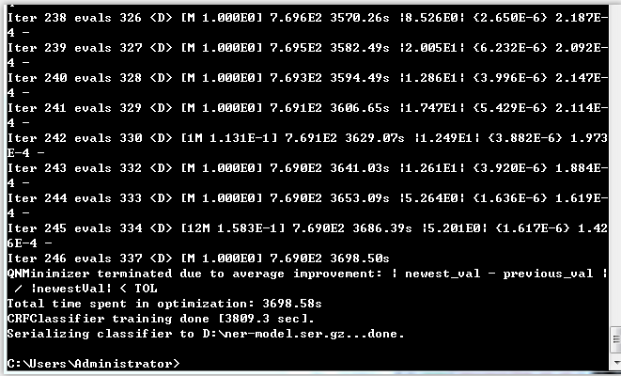
The picture shows the training time and process

Test.py is a python program to test the model

Check.py is a python program to check the test articles with Stanford seven–class recognizer.

Modify.py is a python program to select the sentences which contains conflict between mymodel and Stanford recognizer.

And the result folder contains some results from the above python program.

